Name: ____________________________________ Date: ______________________ Per: _____

Osmosis and tonicity (3:29)   <http://www.youtube.com/watch?v=6MWl3DCa2uM>

Solute = _________________________________ Solvent = ___________________________________________

Osmosis = ______________________________________________________________________________________

Tonicity = _______________________________________________________________________________________

**Tonicity** = _____________________ = _____________________

_______________________________________________________________________________________________________________________

This is a This is an This is a

_____________________ ____________________ ____________________

solution. solution. solution.

(The concentration of water is (The concentration of water is

**lower inside of the bag** now **higher in the bag** than

than that of the beaker). that of the beaker).

[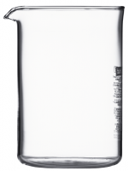](https://www.espressosupply.com/sites/all/files/imagecache/product_full/B1504-10.png)

____________________________ ____________________________ __________________________

A B C

100 ml H2O 100 ml 25% sugar, _____% H2O 100 ml 50% sugar, _____% H2O

In conclusion: In both beakers A and C ***water*** moved from _____________________ to __________________

The water diffused toward areas of _______________________ concentrations.

“High to low is the way to go!”